Creating a Hyperlink in Digication
TLT Student Consultant Help Desk | (631) 632-9602
Stony Brook University | helpme@stonybrook.edu
Chat: www.stonybrook.edu/helpme | it.stonybrook.edu

In this document, you will learn how to:
- Log into Digication and access your ePortfolio
- Add Pages/Modules
- Add/Edit Rich Text Modules
- Create a hyperlink

Logging into Digication and Access your ePortfolio
- You can access Digication by going to https://stonybrook.digication.com and signing in with your NetID and NetID Password (For NetID help, please visit: http://it.stonybrook.edu/services/netid)
- Once you log in using your NetID and NetID password, you will be taken to your Digication Home Page
- Click on the title of the ePortfolio you want to create a hyperlink under “My e-Portfolios”
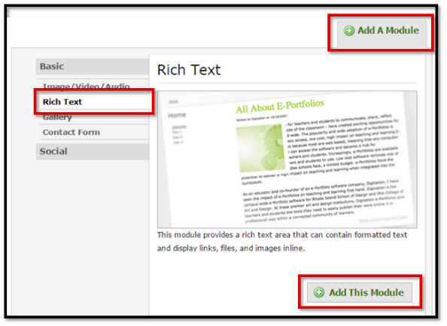
Adding/Editing modules
Before creating a hyperlink, you must select/create sections (horizontal organizational tabs) and/or pages (vertical organizational tabs). Once you are on the proper page to build content, it’s recommended to use a Rich Text module to create a hyperlink.
- To create a new Rich Text module click Add A Module, select Rich Text and click Add This Module
- To edit an existing Rich Text module, click the Edit tab (next to View Text).

Create a Hyperlink
To create a hyperlink, there must be an object to select (text or image). When an object is selected, the Hyperlink icons illuminate. You may only test a hyperlink in the view mode.
- Type text and/or select text.
- Select the Insert/Edit Link icon.
- Paste a hyperlink (e.g. Sharing link from a Google Doc) in the Link URL field.
- Select the Target to “Open Link in a New Window” when sending viewers outside of your eportfolio.
“Open Link in the Same Window” should be used for linking within your eportfolio.
- Title the link for when the mouse hovers over the hyperlink.
- Click Insert.
- Click Save
- Click Publish and confirm the Publish to make any changes viewable to instructors/viewers
- Click View Text to test hyperlink

